机器学习第三章习题
3.1
在样本$x$中有某一个属性${ x}_{i}$为固定值时。那么此时${ x}_{i}w_{i}+b$等价于偏置项，此时${ x}_{i}w_{i}+b$ 与 $b$ 等价。
3.3
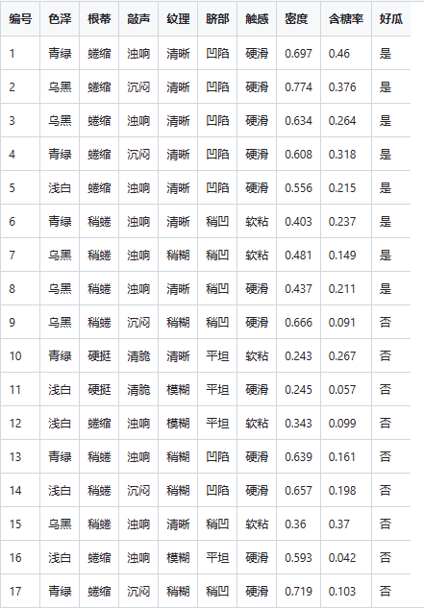
3.5
import numpy as np
import pandas as pd
from matplotlib import pyplot as plt
class LDA(object):
def fit(self, X_, y_, plot_=False):
pos = y_ == 1
neg = y_ == 0
X0 = X_[neg]
X1 = X_[pos]
u0 = X0.mean(0, keepdims=True) # (1, n)
u1 = X1.mean(0, keepdims=True)
sw = np.dot((X0 - u0).T, X0 - u0) + np.dot((X1 - u1).T, X1 - u1)
w = np.dot(np.linalg.inv(sw), (u0 - u1).T).reshape(1, -1) # (1, n)
if plot_:
fig, ax = plt.subplots()
ax.spines['right'].set_color('none')
ax.spines['top'].set_color('none')
ax.spines['left'].set_position(('data', 0))
ax.spines['bottom'].set_position(('data', 0))
plt.scatter(X1[:, 0], X1[:, 1], c='k', marker='o', label='good')
plt.scatter(X0[:, 0], X0[:, 1], c='r', marker='x', label='bad')
plt.xlabel('密度', labelpad=1)
plt.ylabel('含糖量')
plt.legend(loc='upper right')
x_tmp = np.linspace(-0.05, 0.15)
y_tmp = x_tmp * w[0, 1] / w[0, 0]
plt.plot(x_tmp, y_tmp, '#808080', linewidth=1)
wu = w / np.linalg.norm(w)
# 正负样板店
X0_project = np.dot(X0, np.dot(wu.T, wu))
plt.scatter(X0_project[:, 0], X0_project[:, 1], c='r', s=15)
for i in range(X0.shape[0]):
plt.plot([X0[i, 0], X0_project[i, 0]], [X0[i, 1], X0_project[i, 1]], '--r', linewidth=1)
X1_project = np.dot(X1, np.dot(wu.T, wu))
plt.scatter(X1_project[:, 0], X1_project[:, 1], c='k', s=15)
for i in range(X1.shape[0]):
plt.plot([X1[i, 0], X1_project[i, 0]], [X1[i, 1], X1_project[i, 1]], '--k', linewidth=1)
# 中心点的投影
u0_project = np.dot(u0, np.dot(wu.T, wu))
plt.scatter(u0_project[:, 0], u0_project[:, 1], c='#FF4500', s=60)
u1_project = np.dot(u1, np.dot(wu.T, wu))
plt.scatter(u1_project[:, 0], u1_project[:, 1], c='#696969', s=60)
ax.annotate(r'u0 投影点',
xy=(u0_project[:, 0], u0_project[:, 1]),
xytext=(u0_project[:, 0] - 0.2, u0_project[:, 1] - 0.1),
size=13,
va="center", ha="left",
arrowprops=dict(arrowstyle="->",
color="k",
)
)
ax.annotate(r'u1 投影点',
xy=(u1_project[:, 0], u1_project[:, 1]),
xytext=(u1_project[:, 0] - 0.1, u1_project[:, 1] + 0.1),
size=13,
va="center", ha="left",
arrowprops=dict(arrowstyle="->",
color="k",
)
)
plt.axis("equal") # 两坐标轴的单位刻度长度保存一致
plt.show()
self.w = w
self.u0 = u0
self.u1 = u1
return self
def predict(self, X):
project = np.dot(X, self.w.T)
wu0 = np.dot(self.w, self.u0.T)
wu1 = np.dot(self.w, self.u1.T)
return (np.abs(project - wu1) < np.abs(project - wu0)).astype(int)
if __name__ == '__main__':
data_path = r'C:\Users\watermelon3_0_Ch.csv'
data = pd.read_csv(data_path).values
X = data[:, 7:9].astype(float)
y = data[:, 9]
y[y == '是'] = 1
y[y == '否'] = 0
y = y.astype(int)
lda = LDA()
lda.fit(X, y, plot_=True)
print(lda.predict(X)) # 和逻辑回归的结果一致
print(y)

3.6
答：引入核函数

